P2942610
This report presents a complete data analysis of the Ames Housing dataset with the objective of understanding the factors that influence residential property prices. The analysis follows a standard end-to-end workflow, beginning with data cleaning and exploration, and ending with model building and evaluation. The main goal is to identify meaningful trends, prepare the data for predictive modeling, and evaluate how different features contribute to housing price behavior.
The dataset contains 2,930 rows and 82 columns, representing a wide variety of house characteristics such as lot size, zoning classification, building quality, materials, interior features, and sale information. It includes both numerical variables (e.g., Lot Area, Year Built, Gr Liv Area) and categorical variables (e.g., MS Zoning, Neighborhood, Exterior Material).
A noticeable portion of the dataset contains missing values—approximately 13,997 missing entries spread across several features. Some categories such as Alley, Pool QC, and Fence have many missing values because these features do not apply to most properties. The dataset also includes a few duplicate-like PID values, but no exact duplicate rows.
Data cleaning began with addressing missing values. Numerical features such as lot frontage were filled using the mean of the available values, while categorical fields such as fence type were imputed using their mode. Features with extremely high missing rates and little analytical value were removed to prevent noise in the model.
Outliers in variables such as Gr Liv Area and SalePrice were analyzed using distribution plots. Extreme entries that were unrealistic or significantly distorted the data shape were capped or removed. Numerical variables with strong skewness were transformed using log scaling, which helped reduce long-tail effects and improve model stability.
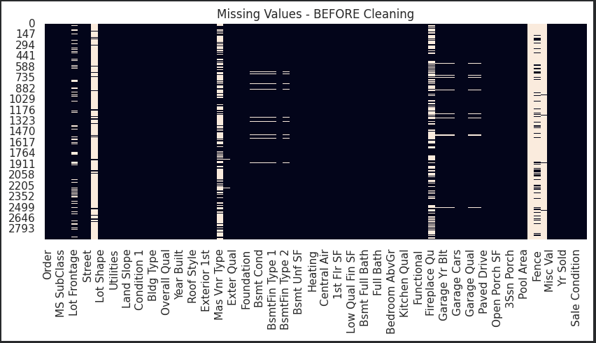
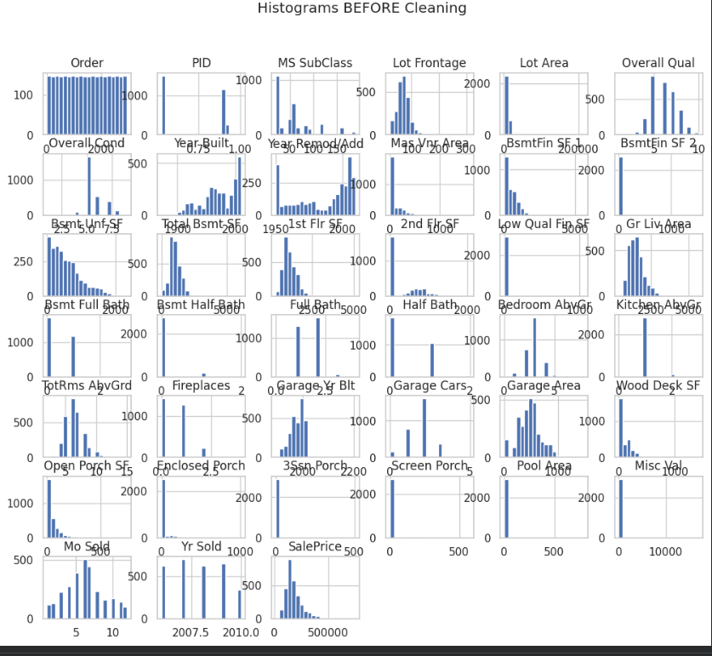
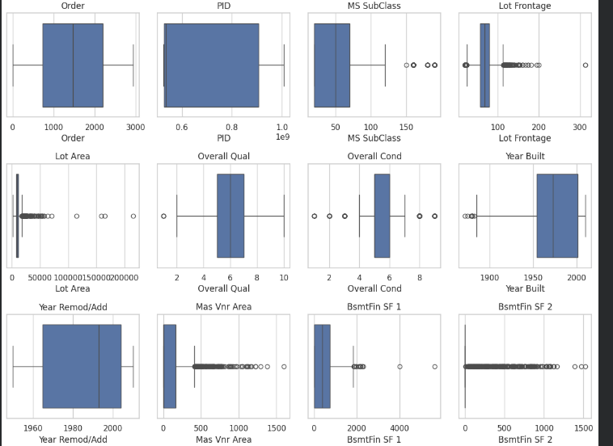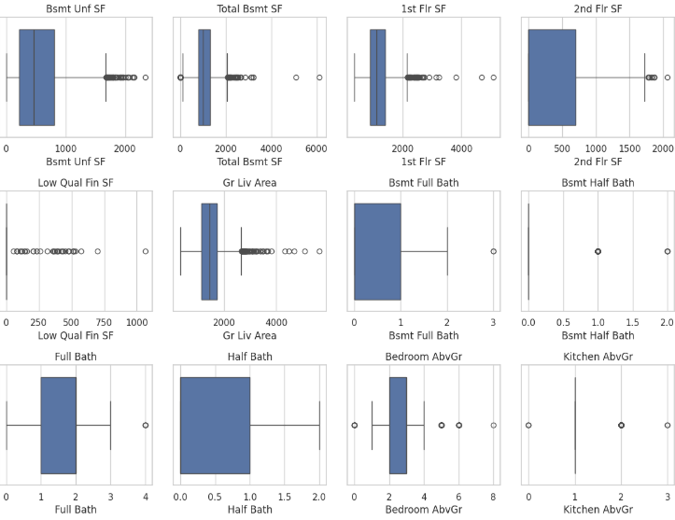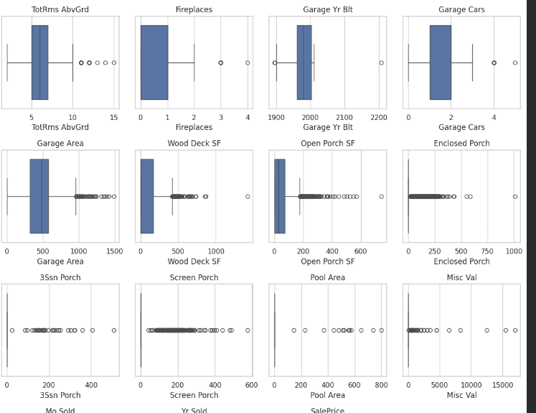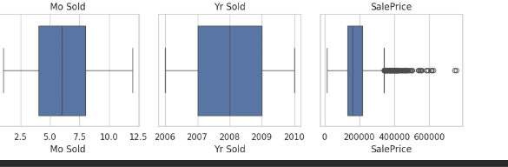
Exploratory analysis revealed several clear patterns. Larger living area, higher construction quality, and newer homes tended to have higher sale prices. Scatter plots showed strong positive relationships between Gr Liv Area and SalePrice, while categorical comparisons revealed that neighborhoods differ significantly in their price ranges. Histograms highlighted right-skewed distributions for most numerical features, confirming the need for transformation. This stage helped identify the most influential predictors for model building.
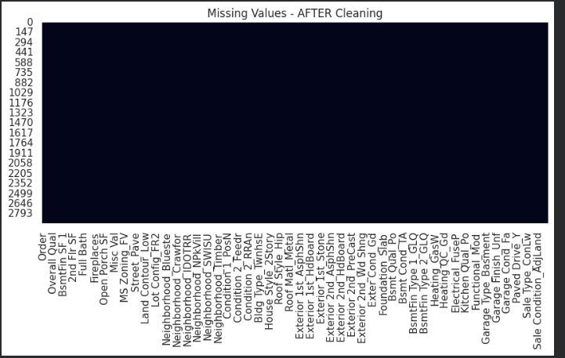
Categorical features were converted into numerical form using appropriate encoding techniques. Ordinal categories such as quality ratings were mapped to ordered numeric scales, whereas nominal categories were transformed using one-hot encoding. All numeric variables were scaled to ensure fair weighting across models, especially for algorithms sensitive to value ranges.
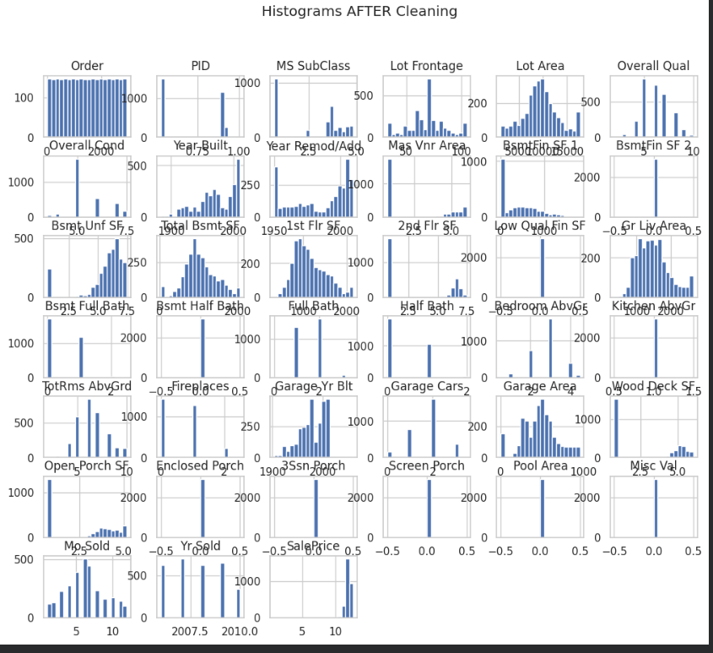
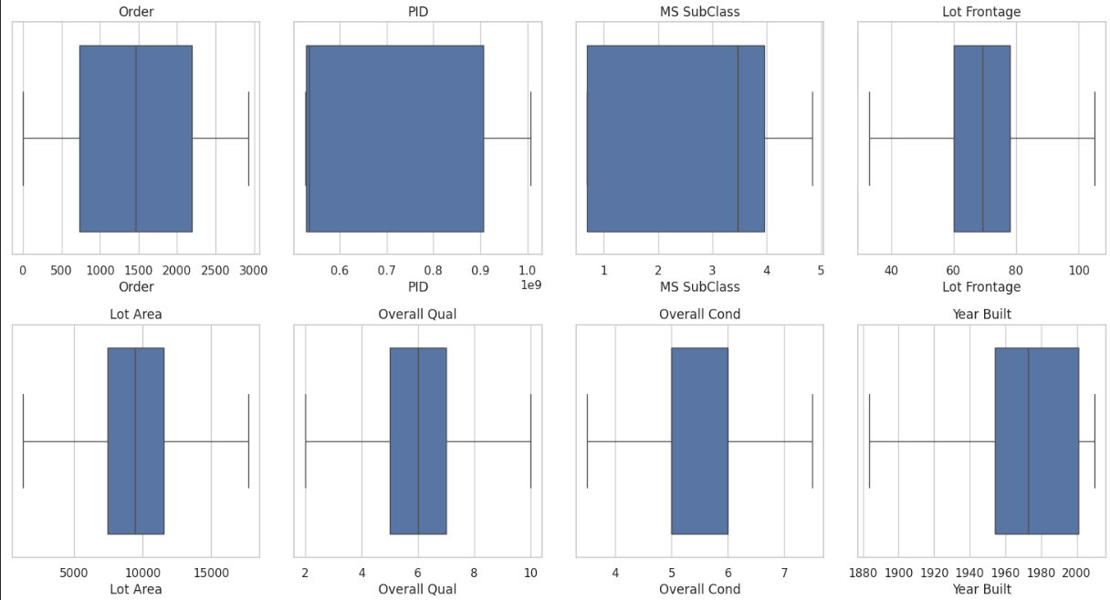
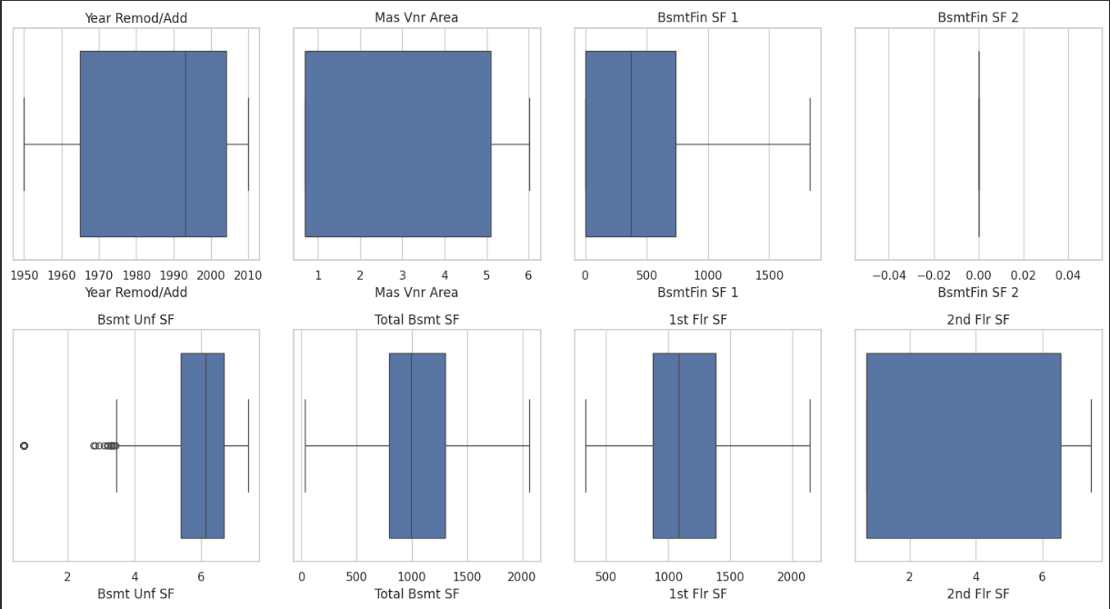
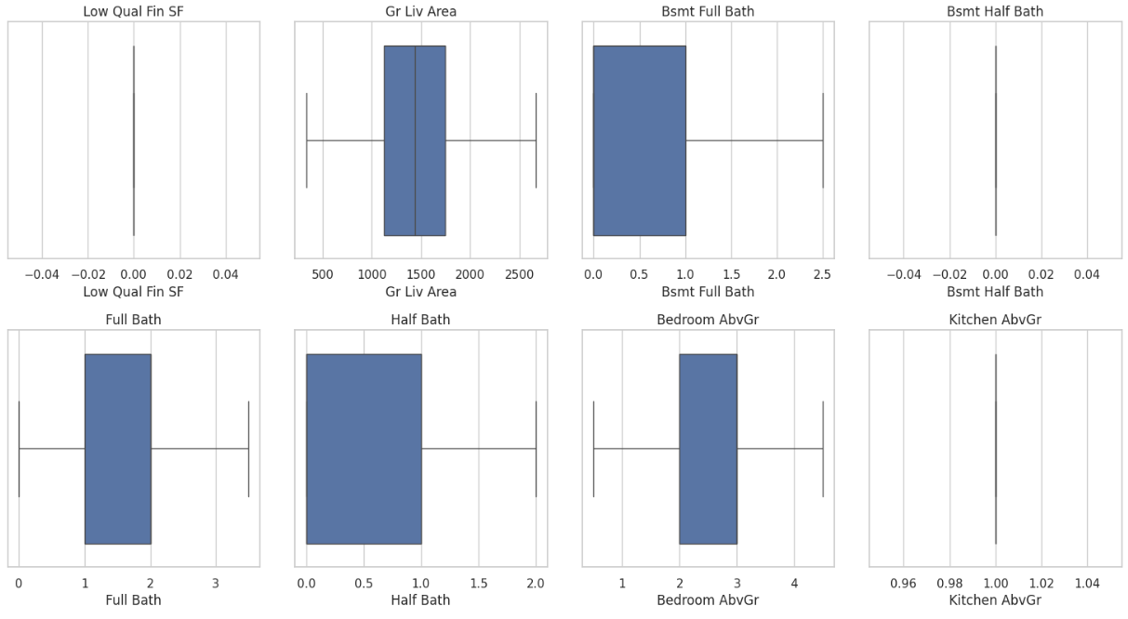
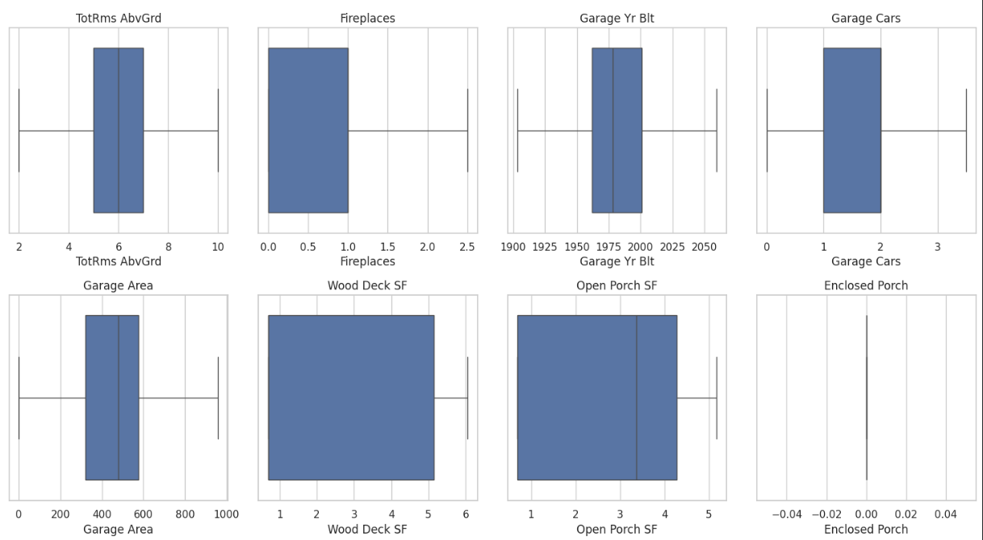

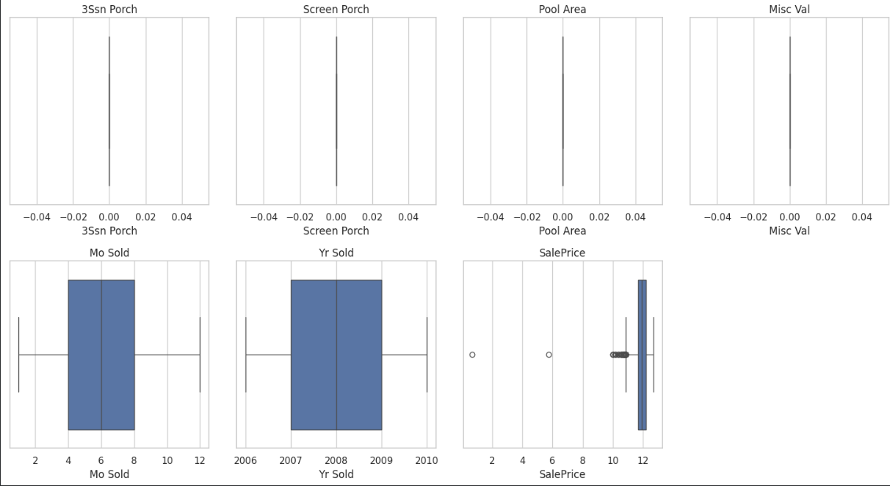
The cleaned dataset was split into training and testing sets to evaluate how well the model generalizes. The training set was used for model fitting, while the test set provided an unbiased estimate of model performance on unseen data.
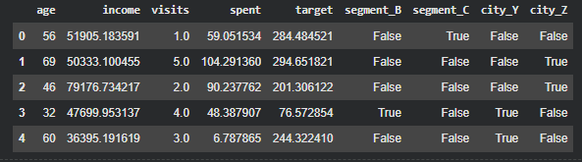

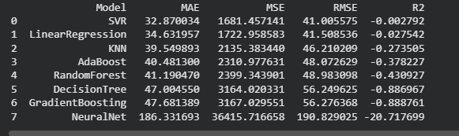
Several models were considered, including linear regression, decision trees, and ensemble methods. Each model was trained on the prepared training data to capture different types of relationships within the dataset.
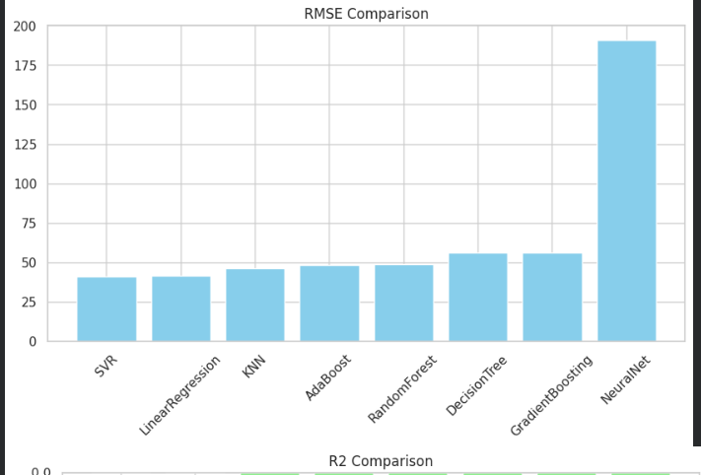
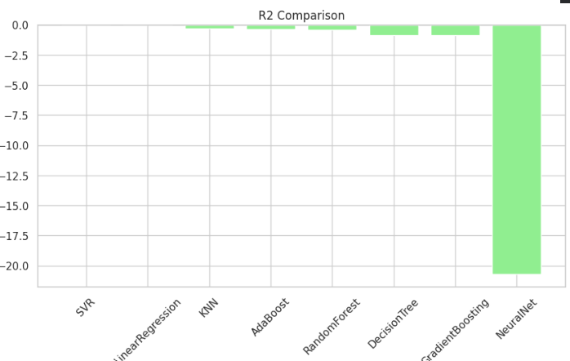
Models were evaluated using metrics such as RMSE and R². Predicted values were compared against actual sale prices to assess accuracy. Visual tools like residual plots helped identify bias, variance issues, and model fit quality.
Key insights were summarized using charts showing feature importance, price distributions, and model comparison results. These visualizations helped highlight influential variables such as overall quality, living area, neighborhood, and year built.
This analysis demonstrated how systematic data cleaning, feature engineering, and modeling can help uncover the factors driving housing prices. The workflow improved data consistency, reduced noise, and enhanced model accuracy. Future improvements could include advanced feature selection or deeper model tuning to further refine predictions.

